**S.V.G.M. GOVERNMENT DEGREE COLLEGE**

**KALYANDURG**

 **NAAC with ‘B’ Grade**





**Coaching for**

**Competitive Exams**

**&**

**P.G Entrance**

**2022-2023**

**Circular**

Date: 25-01-2023

To: All Students

Subject: Free Competitive Examinations Training Program

With the kind permission of Dr. D. Jayarama Reddy, Principal of SVGM Govt. Degree College, Kalyandurg, we are pleased to announce that Sri M. Lakshmi Narayana, Lecturer in Commerce, will be conducting a Free Competitive Examinations Training Program.

Program Details:

Duration: 30 days

Commencement Date: 27th January 2023

Training Includes:

PG M.Com and other Competitive exams related with Accountancy Subject Example Junior Accounts Officer.

Entrance Preparation (30 days): Comprehensive coaching covering essential topics such as Financial Accounting, Business Organization & Management, Cost & Management, Business Economics and Income Tax.

Date: 10th March 2023

For: PG M.Com Entrance Preparation (30 days)

Registration:

Interested students are requested to register for the Free Competitive Examinations Training Program at the Commerce Department.

Sd/-

M. Lakshmi Narayana

Lecturer in Commerce

SVGM Govt. Degree College, Kalyandurg

**Summary Report:**

**Free Competitive Examinations Training Program**

With the gracious permission of Dr. D. Jayarama Reddy, Principal of SVGM Govt. Degree College, Kalyandurg, Sri M. Lakshmi Narayana, Lecturer in Commerce spearheaded a commendable initiative to provide free Competitive Examinations training to students. The program commenced on 27th January 2023 and spanned a duration of 30 days.

**Overview:**

The Free Competitive Examinations Training Program catered to the diverse needs of students preparing for a multitude of competitive exams, including PG M.Com Entrance and Other Competitive Exams related with Accounting. Under the expert guidance of Sri M. Lakshmi Narayana, U. Eswar Reddy and B.K.Ganesh Rao participants received comprehensive coaching and support to enhance their preparation.

**Training Highlights:**

**PG Computer Science Entrance Preparation (30 days):** The program offered rigorous coaching covering essential subjects such as Financial Accounting, Business Organization & Management, Cost & Management, Business Economics, Income Tax and fundamentals of Computers.

**Mock Exam:**

As a pivotal component of the training program, a mock exam was conducted on 10th March 2023, replicating the format and conditions of PG M. Com Entrance exams. This mock exam provided participants with an invaluable opportunity to assess their preparedness and refine their strategies for the actual examinations.

**Conclusion:**

The Free Competitive Examinations Training Program, conducted under the leadership of Sri M. Lakshmi Narayana, has made a significant impact on the preparation and confidence levels of students aspiring to Commerce Subjects in competitive exams. Through dedicated coaching, expert guidance, and rigorous mock tests, participants have been empowered to pursue their academic and career aspirations with confidence.

Sincerely,

M. Lakshmi Narayana

Lecturer in Commerce,

SVGM Govt. Degree College, Kalyandurg.

**2022-23**

**Model PG Entrance Exam**

**Department of Commerce,**

**SVGM Govt. Degree College, Kalyandurg**

**Multiple Choice Questions Answer all the Questions 25 x 1 = 25**

**Section – A: Financial Accounting**

**1.** What is the primary purpose of financial accounting?

a. Internal decision-making b. External reporting to stakeholders

c. Budgeting and forecasting d. Cost analysis

**2.** Which accounting principle states that revenue should be recognized when earned and expenses when incurred?

a. Matching principle b. Revenue recognition principle

c. Going concern principle d. Conservatism principle

**3.** Which financial statement provides information about a company's financial position at a specific point in time?

a. Income statement b. Statement of cash flows

c. Balance sheet d. Retained earnings statement

**4.** What is the accounting equation?

a. Assets = Liabilities + Equity b. Assets = Revenue - Expenses

c. Liabilities = Assets + Equity d. Equity = Assets - Liabilities

**5.** Depreciation is a process of allocating the cost of:

a. Intangible assets b. Current assets

c. Long-term liabilities d. Tangible assets over their useful life

**Section – B: Business organization & Management**

**1.** What is the primary function of management in an organization?

a. Production b. Innovation

c. Marketing d. Planning, organizing, leading, and controlling

**2.** Which of the following is not a level of management in the traditional organizational hierarchy?

a. Top-level management b. Middle-level management

c. Operational management d. External management

**3.** The process of setting organizational goals and determining the best means to achieve them is known as:

a. Controlling b. Organizing c. Planning d. Leading

**4.** What does SWOT analysis stand for in strategic management?

a. Strengths, Weaknesses, Opportunities, Threats

b. Strategy, Work, Objectives, Tactics

c. Structure, Workflow, Organization, Technology

d. Success, Wealth, Objectives, Targets

**5.** Which management function involves arranging resources and tasks to achieve organizational objectives?

a. Planning b. Organizing c. Leading d. Controlling

**Section – C: Income Tax**

**1.** What is the purpose of income tax?

a. To fund government operations b. To regulate businesses

c. To control inflation d. To provide social security benefits

**2.** In the context of income tax, what does "AGI" stand for?

a. Adjusted Gross Income b. Annual Gross Income

c. Average Gross Income d. Actual Gross Income

**3.** Which of the following is a deductible business expense for tax purposes?

a. Personal vacation expenses b. Business-related travel expenses

c. Entertainment expenses for personal use d. Charitable contributions

**4.** What is the standard deduction for a single individual in the United States for the tax year 2023?

a. $12,950 b. $18,800 c. $24,800 d. $32,500

**5.** How is long-term capital gains tax typically treated compared to short-term capital gains tax?

a. Long-term capital gains tax rates are higher

b. Long-term capital gains tax rates are lower

c. Both are taxed at the same rate d. Long-term gains are not taxable

**Section – D: Fundamentals of Computers**

**1.** What does CPU stand for?

a. Central Processing Unit b. Central Peripheral Unit

c. Computer Processing Unit d. Central Program Unit

**2.** Which of the following is a volatile memory type?

a. Hard Disk Drive b. Random Access Memory (RAM)

c. Read-Only Memory (ROM) d. Solid State Drive

**3.** What is the primary purpose of the motherboard in a computer?

a. Execute programs b. Provide power to components

c. Connect and control other hardware components

d. Store data permanently

**4.** What is the function of an operating system?

a. Control the computer's hardware

b. Provide mathematical calculations

c. Manage internet connections

d. Create documents and spreadsheets

**5.** Which of the following is a secondary storage device?

a. RAM b. CPU c. Hard Disk Drive (HDD) d. Motherboard

**Section – E: Cost & Management Accounting**

1. What is the primary purpose of cost accounting?

a. Financial reporting b. Decision-making

c. Tax compliance d. Budgeting

2. Which of the following is a variable cost?

a. Rent b. Direct labor c. Depreciation d. Insurance

3. What is the formula for calculating the contribution margin ratio?

a. Contribution Margin / Sales b. Sales / Contribution Margin

c. Contribution Margin / Total Costs d. Total Costs / Contribution Margin

4. In absorption costing, which costs are treated as product costs?

a. Variable manufacturing costs b. Fixed manufacturing costs

c. Variable selling and administrative costs.

d. Fixed selling and administrative costs

5. What is the formula for calculating the break-even point in units?

a. Fixed Costs / Contribution Margin Ratio

b. Contribution Margin Ratio / Fixed Costs

c. Fixed Costs / Contribution Margin per Unit

d. Contribution Margin per Unit / Fixed Costs

**Photo Evidences**:

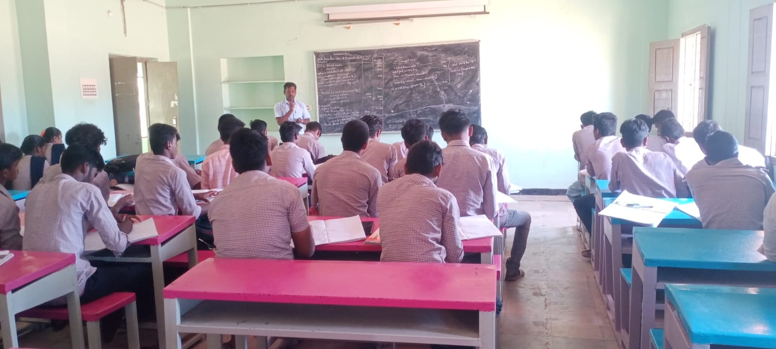

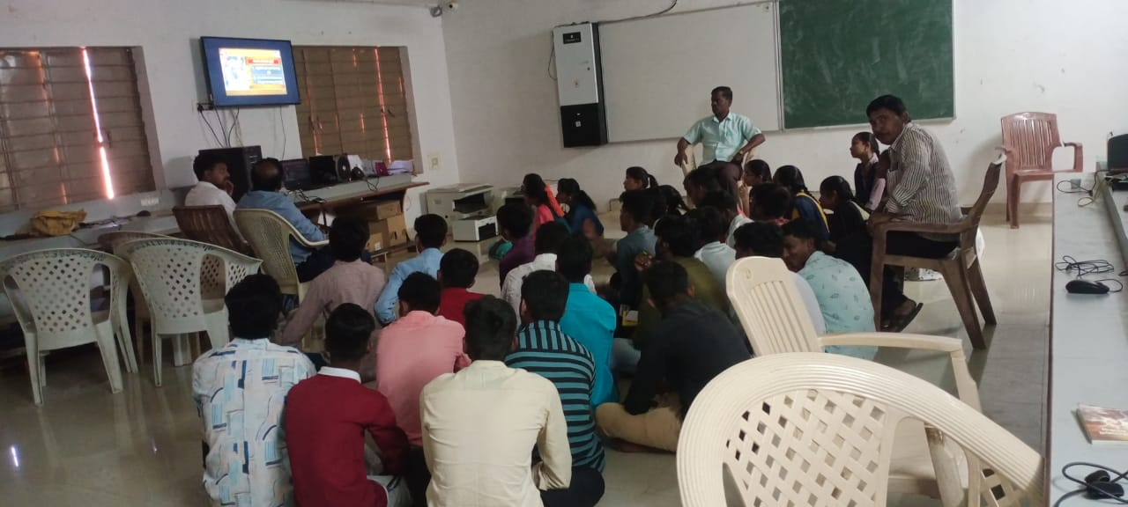

Photos for Evidence

